ASSIGNMENT 2

**Exercise 3: Create a Pod using a YAML Manifest.**

**Objective: Define and deploy a pod using YAML.**

**Step 1: Create a YAML file (nginx-pod.yaml):**



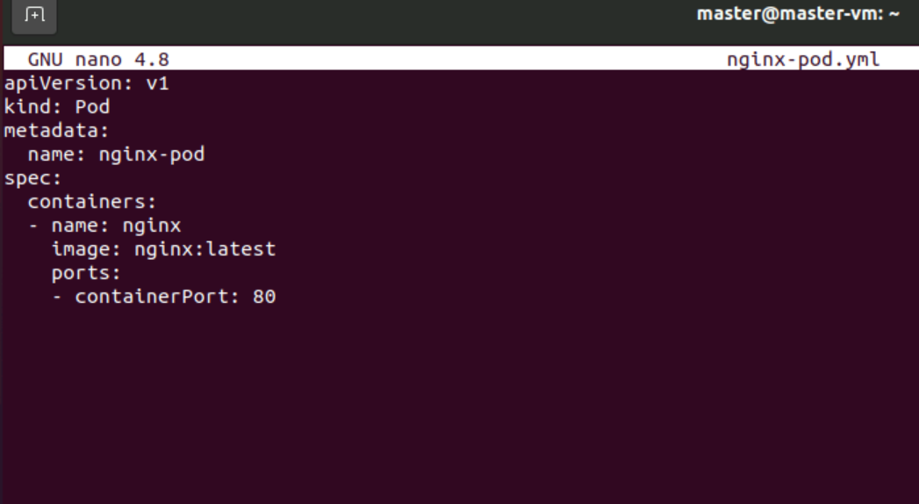

**Step 2: Apply the YAML file:**



**Step 3: Check if the pod is running:**



**Step 4: Delete the pod using YAML:**



**Exercise 4: Create and Use a ConfigMap**

**Objective:** Store environment variables in a ConfigMap and use it in a pod.

**Step 1 :**Create a ConfigMap:



**Step 2:** Verify ConfigMap:

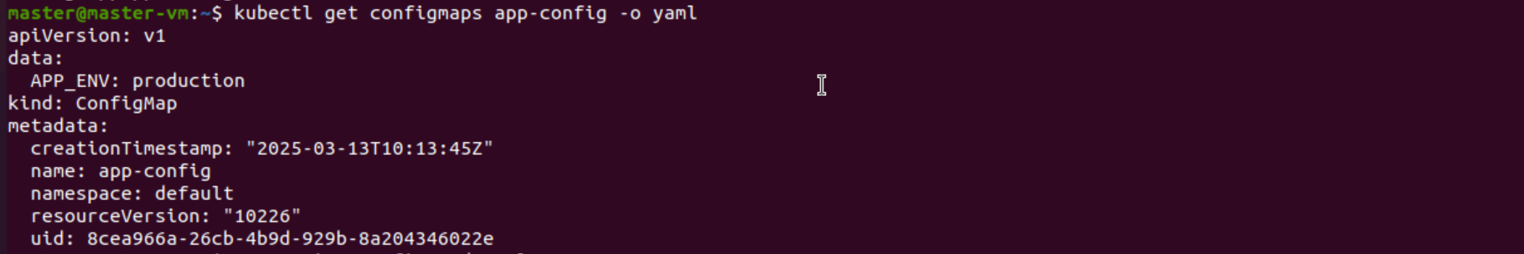

**Step 3:** Create a pod that uses the ConfigMap (nginx-config-pod.yaml):



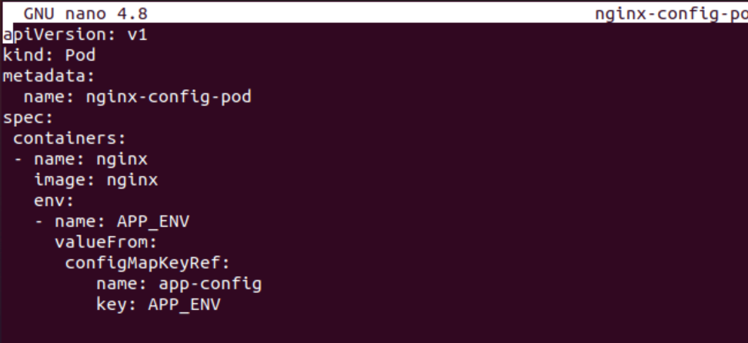

**Step 4:** Deploy the pod:



**Step 5:** Check if the pod is running:

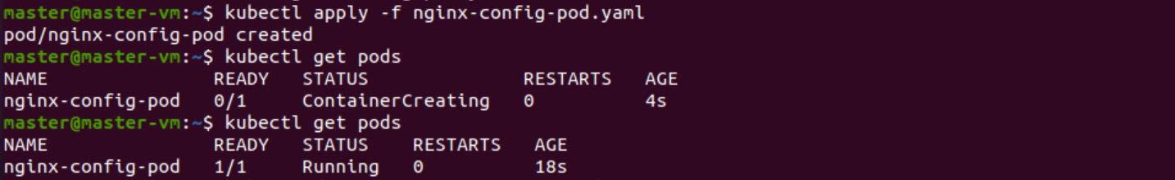

**Step 6:** Delete the pod and ConfigMap: